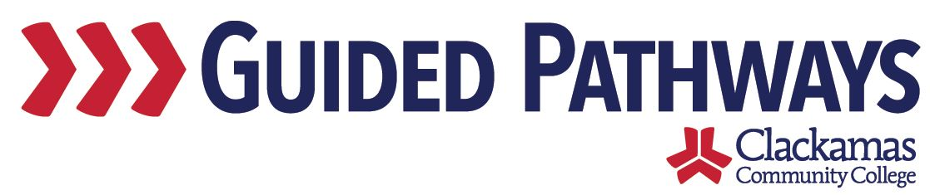
Guided Pathways Leadership Taskforce
Meeting Notes
July 6, 2020, 2:00–3:30 p.m. (Zoom)

- Follow up on previous commitments and updates
- Discussion of leadership and membership changes:
  - Kelly and Dawn are co-chairs – Melissa will no longer be co-chair
  - Carol is on sabbatical next year, Max is leaving the college in August
- Commitments were reviewed:
  - Kelly’s commitment was completed

- Review Self-Assessment
- Self-assessment document:
- Self-assessment work started back in 2017
- Spent several meetings digging into the self-assessment to see where the college was with guided pathways – engaged with that work because we knew it was important for our continued evolution as a guided pathways institution, also completed as part of our application to join the Oregon Pathways cohort (which was a success)
- Want to revisit to see where we are

- Large Group Discussion on Self-Assessment
- There was large group discussion on the current status of essential practices in the self-assessment – updates were discussed
- Max updated the document in real-time

- Discuss and Revise Self-Assessment in Small Groups
- The larger group broke out into three breakouts
- Group 1 focused on 2. HELPING STUDENTS CHOOSE AND ENTER A PATHWAY
  - Dawn, Brittany, Jaime, Lisa R, Marc
- Group 2 focused on 3. KEEPING STUDENTS ON THE PATH
  - Max, Dustin, Jennifer, Lori, Tara
- Group 3 focused on 4. ENSURING THAT STUDENTS ARE LEARNING
  - Kelly, David, Lisa Anh, Nora, Sue

- Large Group Discussion of Findings
- Each group shared out which have been implemented and not implemented, what changes have occurred, discussed updates next steps
- The recorder for each group will send their document to Kelly

- Introduce Next Steps/Conversations
- Kelly will compile each group’s documents into one master document, Sara will send that out
- Use this to come back together to discuss the purpose of the taskforce and what the next steps are for the taskforce
- Use those next steps to see who needs to be in the taskforce and what subgroups need to exist in order to get the work done

- Review commitments and next steps
- Commitments and next steps were reviewed
- The next meeting of the Guided Pathways Taskforce is on Monday, August 3m 2:00-3:30 p.m.

